20CYS403 – Web Application Security
XML, XML SCHEMA, JSON, AJAX AND FETCH API
Ponvedica M S
CB.SC.U4CYS23034
PART A – XML
Create an XML document containing the details of five students.
students.xml
<?xml version="1.0" encoding="UTF-8"?>

<students>
<student>
<registerNumber>23034</registerNumber>
<name>vedica</name>
<department>CYS</department>
<semester>6</semester>
<cgpa>9.02</cgpa>
</student>

<student>
<registerNumber>23045</registerNumber>
<name>soffia</name>
<department>CYS</department>
<semester>6</semester>
<cgpa>8.72</cgpa>
</student>

<student>
<registerNumber>23052</registerNumber>
<name>vedha</name>
<department>CYS</department>
<semester>6</semester>
<cgpa>8.75</cgpa>
</student>

<student>
<registerNumber>23002</registerNumber>
<name>anagha</name>
<department>CYS</department>
<semester>6</semester>
<cgpa>9.16</cgpa>
</student>

<student>
<registerNumber>23334</registerNumber>
<name>renny</name>
<department>AI</department>
<semester>6</semester>
<cgpa>9.57</cgpa>
</student>
</students>

PART B – XML Schema (XSD)
Modify the schema to ensure:
- Semester is between 1 and 8.
- CGPA is between 0 and 10.
Validation is successful here.
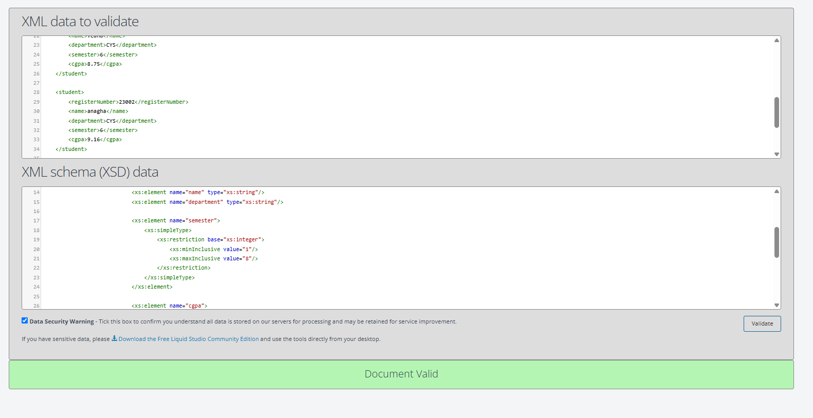

Since, we changed the cgpa to 45 which doesn’t meet the schema requirement of it being in range of 0 to 10.
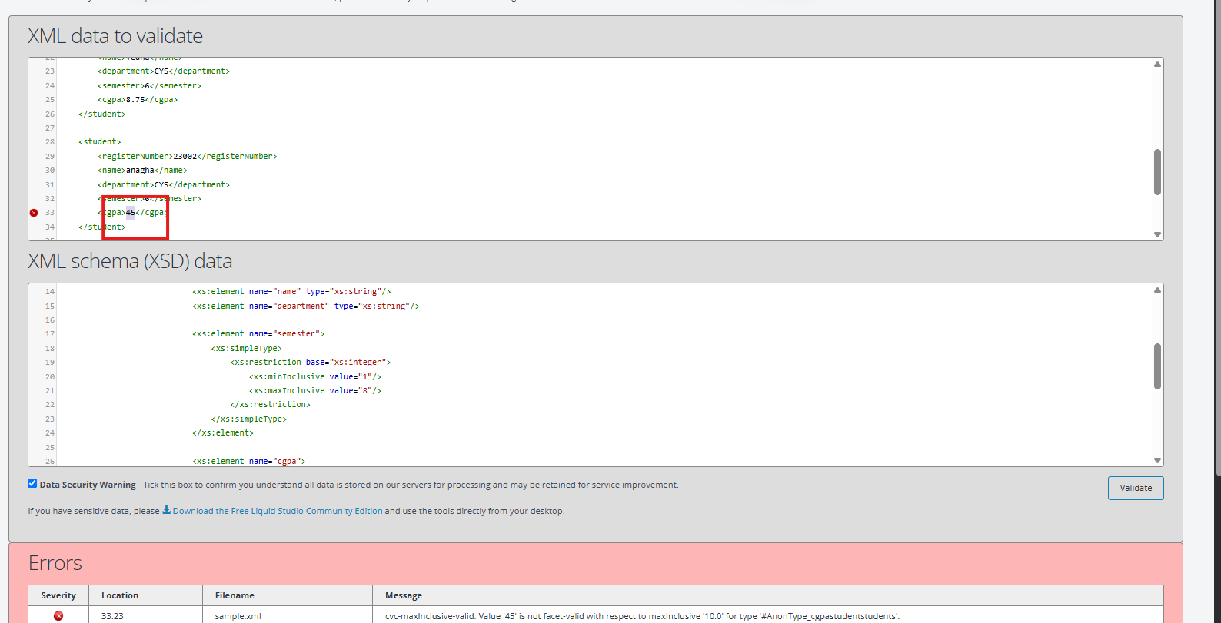
students.xsd
- <?xml version="1.0" encoding="UTF-8"?>

- <xs:schema xmlns:xs="http://www.w3.org/2001/XMLSchema">

- <xs:element name="students">
- <xs:complexType>
- <xs:sequence>

- <xs:element name="student" maxOccurs="unbounded">
- <xs:complexType>
- <xs:sequence>

- <xs:element name="registerNumber" type="xs:string"/>
- <xs:element name="name" type="xs:string"/>
- <xs:element name="department" type="xs:string"/>

- <xs:element name="semester">
- <xs:simpleType>
- <xs:restriction base="xs:integer">
- <xs:minInclusive value="1"/>
- <xs:maxInclusive value="8"/>
- </xs:restriction>
- </xs:simpleType>
- </xs:element>

- <xs:element name="cgpa">
- <xs:simpleType>
- <xs:restriction base="xs:decimal">
- <xs:minInclusive value="0"/>
- <xs:maxInclusive value="10"/>
- </xs:restriction>
- </xs:simpleType>
- </xs:element>

- </xs:sequence>
- </xs:complexType>
- </xs:element>

- </xs:sequence>
- </xs:complexType>
- </xs:element>

- </xs:schema>

PART C – JSON
Create a JSON array containing five students.
students.json
[
{
"registerNumber":"23034",
"name":"Vedica",
"department":"CYS",
"semester":6,
"cgpa":9.02
},
{
"registerNumber":"23045",
"name":"Soffia",
"department":"CYS",
"semester":6,
"cgpa":8.72},
{
"registerNumber":"23052",
"name":"Vedha",
"department":"CYS",
"semester":6,
"cgpa":8.75},
{
"registerNumber":"23002",
"name":"Anagha",
"department":"CYS",
"semester":6,
"cgpa":9.16
},
{
"registerNumber":"23334",
"name":"Renny",
"department":"AI",
"semester":6,
"cgpa":9.57
}
]
PART D – AJAX
Modify the PHP script to return an array of students and display them in an HTML table.
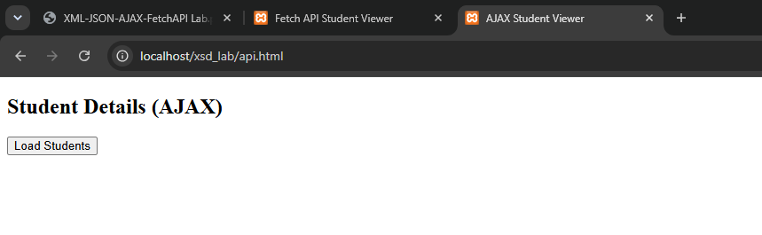
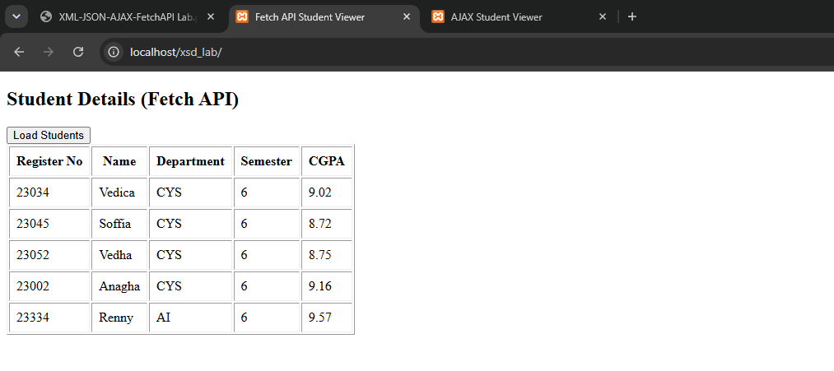
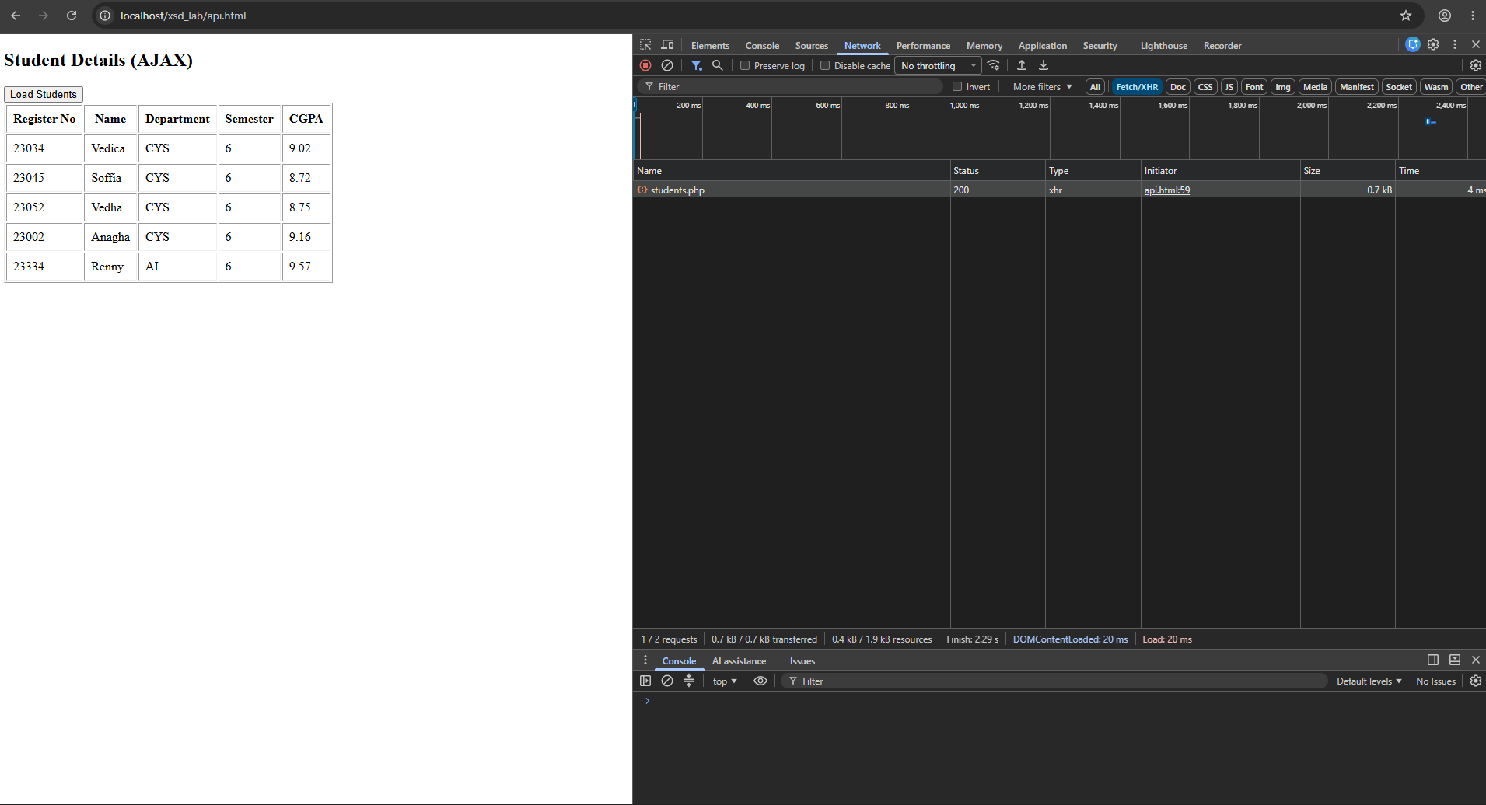
Can see the network response as the xhr here
api.html
<!DOCTYPE html>
<html>
<head>
<title>AJAX Student Viewer</title>
</head>
<body>

<h2>Student Details (AJAX)</h2>

<button onclick="loadStudents()">Load Students</button>

<div id="output"></div>

<script>

function loadStudents(){

let xhr = new XMLHttpRequest();

xhr.open("GET","students.php",true);

xhr.onload = function(){

if(xhr.status == 200){

let students = JSON.parse(xhr.responseText);

let table="<table border='1' cellpadding='8'>";
table+="<tr>";
table+="<th>Register No</th>";
table+="<th>Name</th>";
table+="<th>Department</th>";
table+="<th>Semester</th>";
table+="<th>CGPA</th>";
table+="</tr>";

students.forEach(function(student){

table+="<tr>";
table+="<td>"+student.registerNumber+"</td>";
table+="<td>"+student.name+"</td>";
table+="<td>"+student.department+"</td>";
table+="<td>"+student.semester+"</td>";
table+="<td>"+student.cgpa+"</td>";
table+="</tr>";

});

table+="</table>";

document.getElementById("output").innerHTML=table;
}
else{
document.getElementById("output").innerHTML="Unable to retrieve student data.";
}

};
xhr.send();
}

</script>

</body>
</html>

students.php
<?php

header("Content-Type: application/json");

$students = [

[
"registerNumber"=>"23034",
"name"=>"Vedica",
"department"=>"CYS",
"semester"=>6,
"cgpa"=>9.02
],

[
"registerNumber"=>"23045",
"name"=>"Soffia",
"department"=>"CYS",
"semester"=>6,
"cgpa"=>8.72
],

[
"registerNumber"=>"23052",
"name"=>"Vedha",
"department"=>"CYS",
"semester"=>6,
"cgpa"=>8.75
],

[
"registerNumber"=>"23002",
"name"=>"Anagha",
"department"=>"CYS",
"semester"=>6,
"cgpa"=>9.16
],

[
"registerNumber"=>"23334",
"name"=>"Renny",
"department"=>"AI",
"semester"=>6,
"cgpa"=>9.57
]

];

echo json_encode($students);

?>

PART E – Fetch API
Modify the application so that:
1. The PHP script returns details of five students.
2. The Fetch API retrieves the data.
3. The student information is displayed in an HTML table.
4. Display an appropriate error message if the server cannot be reached.
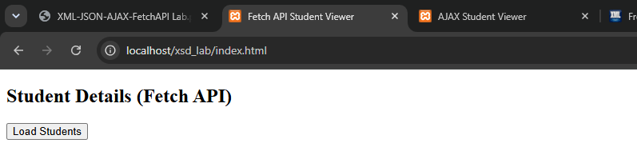
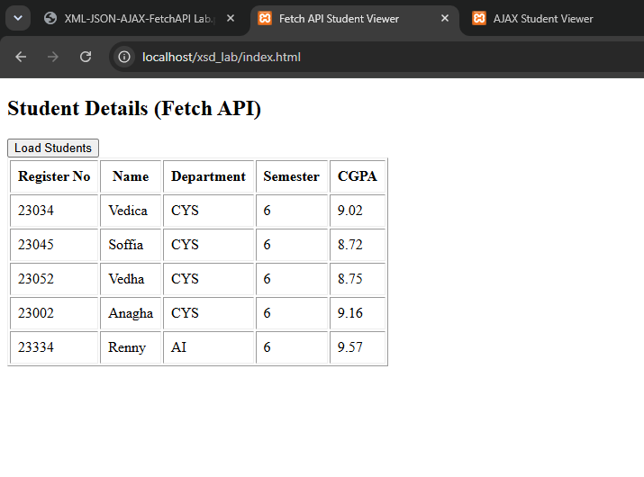

If server can’t be reached, an error message is showed
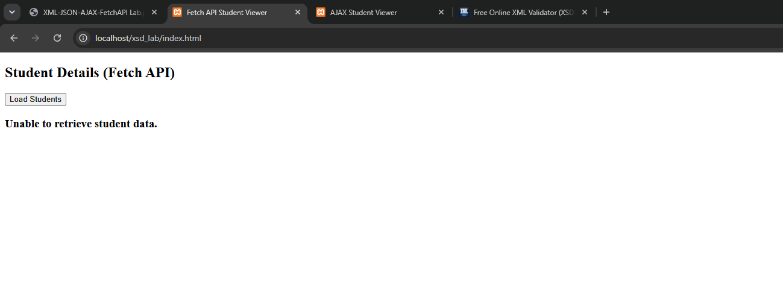
Here, we can see that the fetch in network response
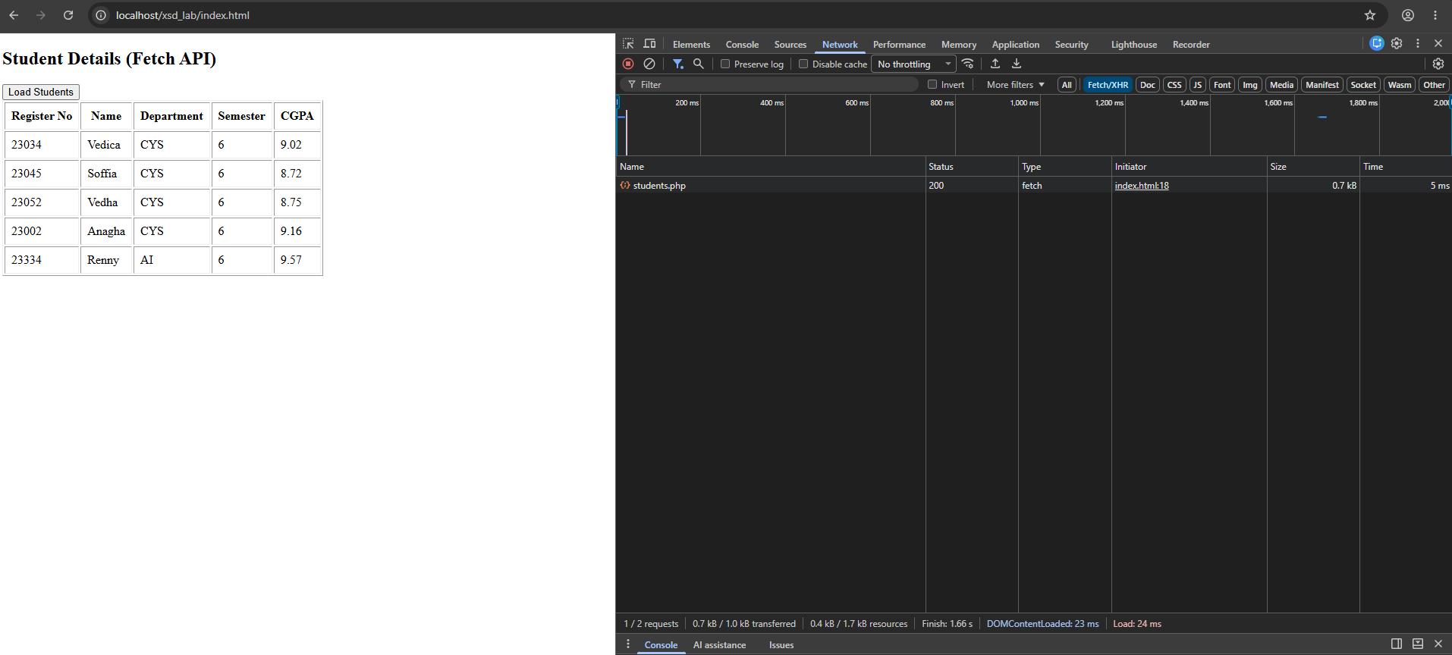

index.html
<!DOCTYPE html>
<html>
<head>
<title>Fetch API Student Viewer</title>
</head>
<body>

<h2>Student Details (Fetch API)</h2>

<button onclick="loadStudents()">Load Students</button>

<div id="output"></div>

<script>

function loadStudents(){

fetch("students.php")

.then(response=>{

if(!response.ok){
throw new Error("Server Error");
}

return response.json();

})

.then(data=>{

let table="<table border='1' cellpadding='8'>";

table+="<tr>";
table+="<th>Register No</th>";
table+="<th>Name</th>";
table+="<th>Department</th>";
table+="<th>Semester</th>";
table+="<th>CGPA</th>";
table+="</tr>";

data.forEach(student=>{

table+="<tr>";
table+="<td>"+student.registerNumber+"</td>";
table+="<td>"+student.name+"</td>";
table+="<td>"+student.department+"</td>";
table+="<td>"+student.semester+"</td>";
table+="<td>"+student.cgpa+"</td>";
table+="</tr>";

});

table+="</table>";

document.getElementById("output").innerHTML=table;

})

.catch(error=>{

document.getElementById("output").innerHTML="<h3>Unable to retrieve student data.</h3>";

console.log(error);

});

}

</script>

</body>
</html>

